A000-US-Apache Chiricahuas-String Fiddle-c 1875

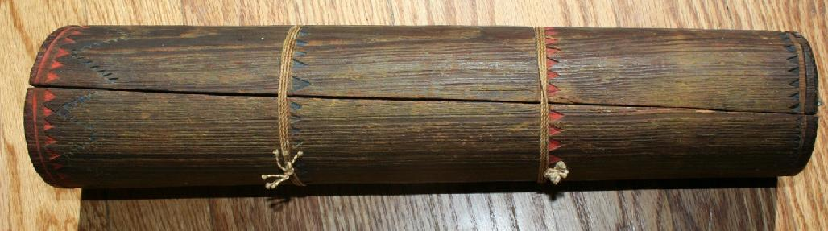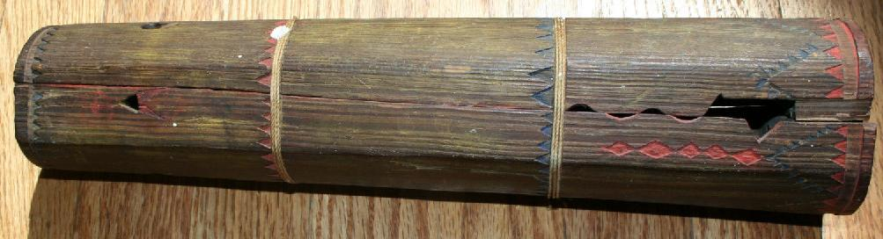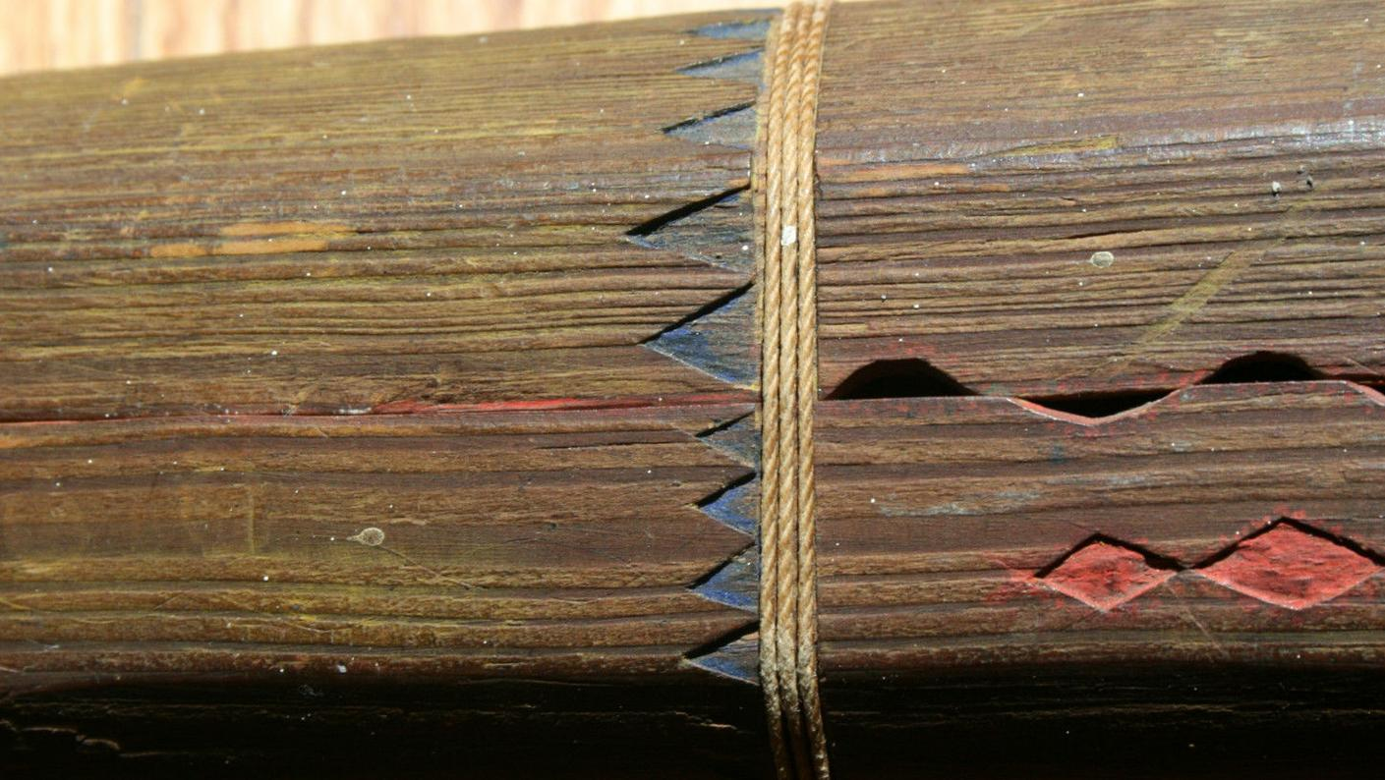

**Case No.:**

**Accession No.**

**Formal Label:**

**Display Description:**

Great early Chiricahua stringed fiddle. Very rare with wonderful original painted and carved details. Red and blue pigments. Measures 14" long. Late 1800's with an unretouched surface. Great dry patina. Good overall condition with a small break and it is missing the string that was used to play it. Fits together loosely. The Warm Springs band (Chihende, or Red Paint People) of the Chiricahuas considered Cañada Alamosa and the waters of Ojo Caliente the heart of their ancestral homeland. The Apache fiddle is a bowed string instrument used by the indigenous Apache people of the southwestern United States. The instrument consists of a plant stalk, such as that of the agave or mescal plant. One or sometimes two strings, often made of horse hair, are secured at both ends of the stalk, a bridge and nut added, and the string is played with a bow rosined with pine pitch. The string is touched with the fingers to change its note.

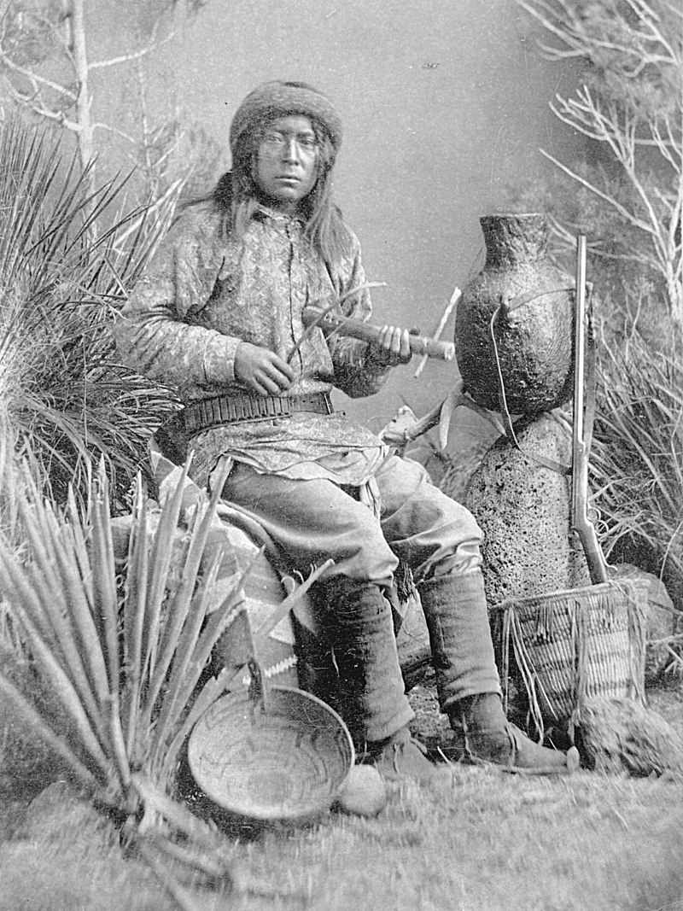 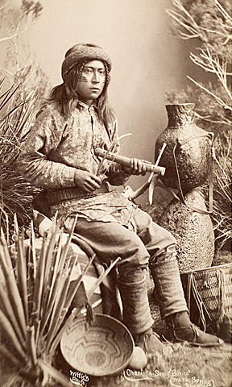

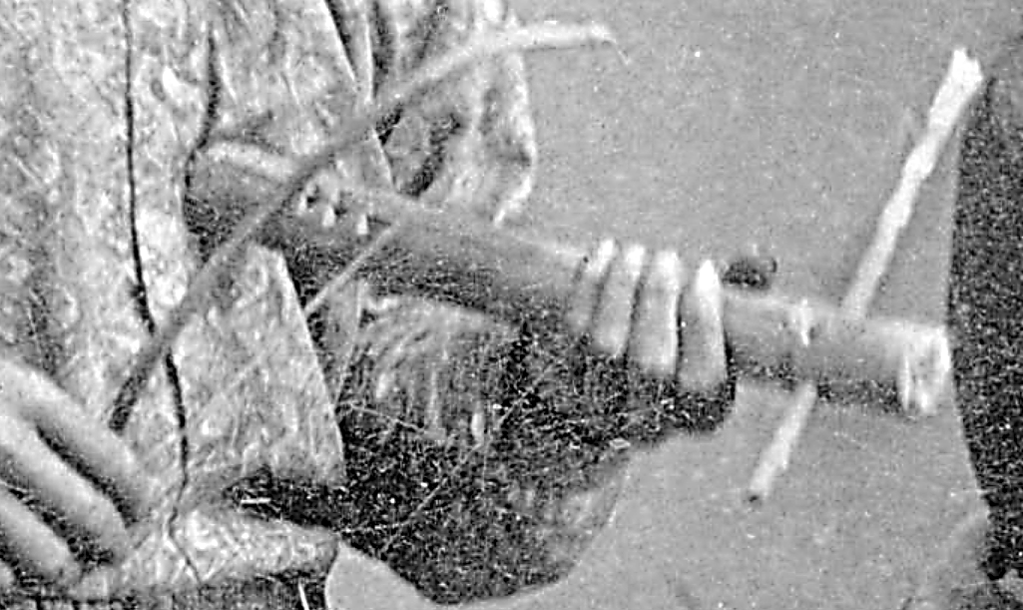

Chasi, a New Mexico Chiricahua (Warm Springs [Ojo Caliente] band) musician playing the Apache fiddle, 1886, photo by A. Frank Randall - [1][2], Public Domain, <https://commons.wikimedia.org/w/index.php?curid=6884544> "Warm Springs " is from the Spanish and most descendants live in Oklahoma today.

**LC Classification:**

**Date or Time Horizon: c 1886**

**Geographical Area:** Cañada Alamosa and the waters of Ojo Caliente

**Map:**

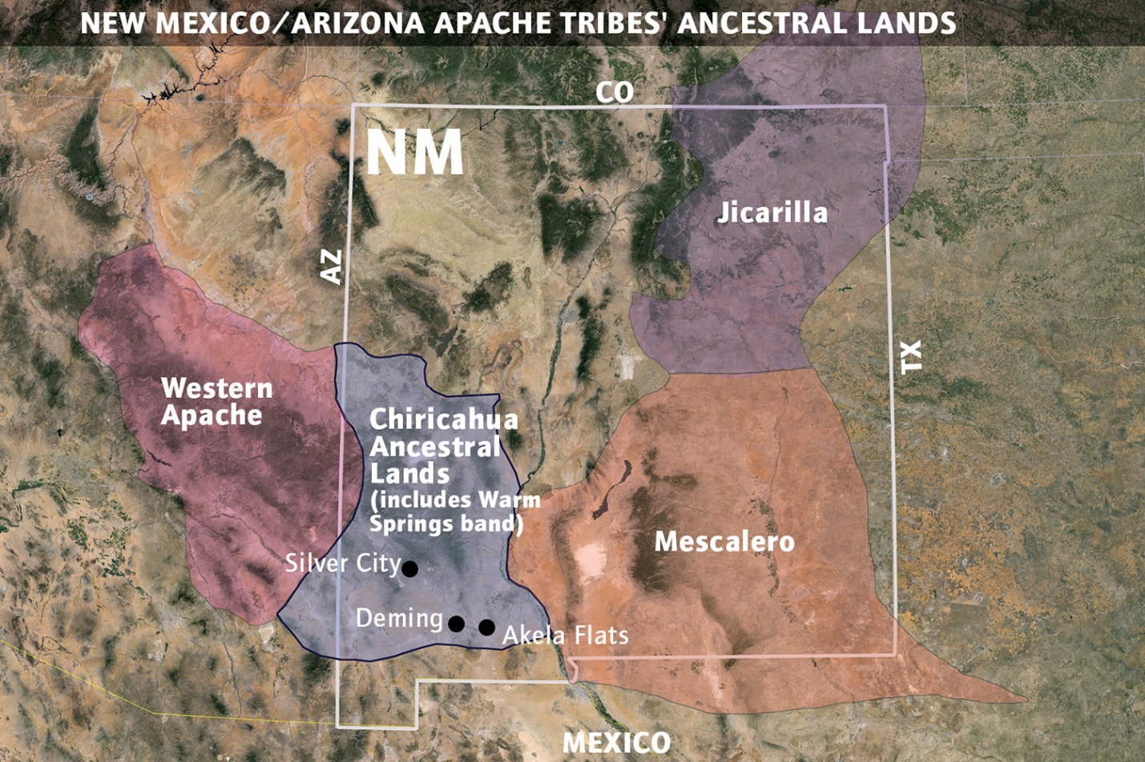

**After https://www.google.com/url?sa=i&source=imgres&cd=&cad=rja&uact=8&ved=2ahUKEwju77biyvTcAhWCUt8KHdbXAlIQjRx6BAgBEAU&url=https%3A%2F%2Fwww.hcn.org%2Fissues%2F45.17%2Fan-okie-apache-fights-his-kin-to-build-a-casino-and-bring-his-people-home&psig=AOvVaw1zcaatPaYkZhADeOF4l1bU&ust=1534612385731728**

**GPS coordinates:**

**Cultural Affiliation:** The [Smithsonian Institution](https://en.wikipedia.org/wiki/Smithsonian_Institution) holds an Apache fiddle collected in 1875. American Indian art magazine Published by American Indian Art, Inc., 1980. Original from the University of Michigan. Digitized Dec 19, 2007. Page 28. This example follows this specimen closely and is therefore extremely rare.

**Media:**

**Dimensions:**

**Weight:**

**Condition:**

**Provenance:**

**Discussion:**

“The Apache Indians in some of their ceremonies made use of a small stringed instrument, of one cord, known as the "Apache fiddle." Several specimens are now in the museum at the University of Pennsylvania. The resonator is a hollow reed about a foot in length, over which is stretched a strand composed of six or eight horse-hairs. The strand is at one end, wrapped around a movable cross-bar, which allows it to be tightened at will. The cord is sounded by means of a bow with a horse-hair string. There is some doubt whether this is a genuine aboriginal invention. The specimens were obtained by Captains Bourke and McCauley of the United States army. The former does not refer to it in his "Medicine Men of the Apaches." The third example is mentioned by James Adair in his History of the American Indians, p. 175. He relates that in 1746 he was among the "Mississippi-Nachee" Indians, and witnessed a performance "on one of their old sacred musical instruments." He described it as "about five feet long and a foot wide on the head part of the board, with eight strings made out of the sinews of a large buffalo." The player "held the instrument between his feet, and alongside of his chin, took one end of the bow, while a lust)' fellow held the other. By sweating labor they scraped out such harsh sounds as might have been sufficient to drive out the devil, if he lay in the house." “ (Brinton 1897: 20)

**References**

* Brinton, Daniel. 1897. “Native American Stringed Musical Instruments,” *The American antiquarian and oriental journal* 19: 20.